Press Release July 2023
For Immediate Release

REAR ADMIRAL JUDE TERRY OBE BECOMES ONE OF GIRLGUIDING SOUTH WEST ENGLAND’S REGIONAL AMBASSADORS

ON FRIDAY 28 JULY GIRLGUIDING SOUTH WEST ENGLAND ANNOUNCED FIRST FEMALE REAR ADMIRAL JUDE TERRY AS A REGION AMBASSADOR IN A BID TO PROVIDE EVEN MORE AMAZING OPPORTUNITIES TO ITS ALMOST 47000 YOUNG MEMBERS AND 11500 VOLUNTEERS
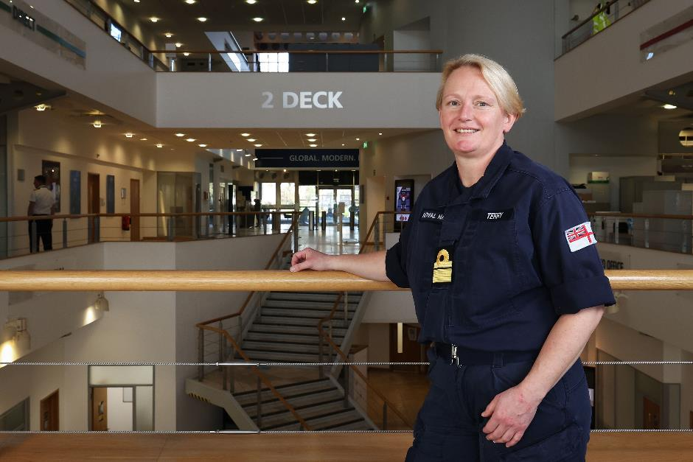

In March 2023 Girlguiding South West England launched their Region ambassador programme – a voluntary scheme designed to help the youth organisation raise awareness about the charity, support volunteers and help to inspire even more young women and girls in our 16 Counties and Islands. South West England ambassadors will help shape the Region by sharing their expertise and making sure we give all girls the chance to be a powerful force for good and helping them know that all girls can do anything.

RAdm Terry has served her nation and Royal Navy for a quarter of a century (26 years this year) and made history in 2022 when she was the first woman officer appointed to the rank of Rear Admiral. She is now one of the most senior women in the Royal Navy, past or present and is currently the Director of People and Training and Naval Secretary.

Jude, from Jersey, joins the Girlguiding South West England Region as an ambassador to support, inspire and provide more opportunities to its members. On joining the ambassador scheme, RAdm Terry said “I’m really excited about being asked to be a Girlguiding South West England ambassador as I grew up in Girlguiding – I was a Brownie and a Guide. I’ve kept connected with Girlguiding throughout my Royal Navy career because my sister has been a leader for over 25 years and currently runs the Jersey Rangers”.

As an ambassador, Jude will support girls in learning how they can overcome any challenges that they may face and to show them that they can be whoever and whatever they want in life. Reflecting on her own time in Girlguiding, Jude said “for me, Girlguiding was a huge influence – it helped me to build my confidence, to challenge myself and provided me with friends and leaders who supported me; particularly after my dad died. Girlguiding really does help girls to know they can do anything, and I look forward to meeting and supporting members across the Region”.

Jude joins the Region’s other existing ambassadors – a Social Media Content Creator, a Football Coach, an NHS dentist, and a former Olympian. The Region will be announcing and launching their other fantastic ambassadors over the next six months, including a children’s author, local politician, and an Earth Scientist.

Girlguiding is the UK’s largest youth organisation dedicated completely to girls. We would like to provide even more opportunities and experiences for girls and young women across our Region. Our volunteers help local girls and young women enjoy a wide range of exciting activities, as well as acquire new skills and experiences – and have fun at the same time. Flexible volunteering is highly encouraged, with lots of different roles on offer for those who want to take a more adaptable approach to Guiding. Being a Girlguiding volunteer could see you going around the world accompanying girls on trips of a lifetime, spending a weekday evening helping girls learn a new skill or enjoying an action-packed outdoors adventure weekend as you make your own lifelong friendships. There are lots of different roles to choose from to fit in with your lifestyle and we will provide all the training and support you need.

We welcome volunteers of all backgrounds, ages, cultures, faiths and abilities. For more information about volunteering with Girlguiding, visit https://www.girlguidingsouthwest.org.uk/join-us.

-ENDS-

Notes to editors:
For further information please contact sarahj@ggswe.org.uk

Photo – Rear Admiral Jude Terry OBE, Crown Copyright 2023

About Girlguiding South West England
Girlguiding South West England is one of the nine Countries and Regions of Girlguiding, the UK’s leading youth organisation for girls and young women. Guiding is offered to Rainbow, Brownie, Guide and Ranger Units throughout the Region’s 16 Guiding Counties and Islands. We help all girls know they can do anything. We help them know that, whether they’re 4 or 18 or in between. All girls have a home at Girlguiding - whoever they are, and wherever they are. We show them a world of possibilities, big and small. We help them think big and be bold in a space where they can be themselves, get creative, explore, and have fun. We’re a powerful collective voice – with girls, led by girls – changing the world for the better.

We’re 47,000 Rainbows, Brownies, Guides and Rangers, who come together to laugh, learn, explore and have adventures, in communities across the UK and virtually. We're 11,500 volunteers who make guiding happen by giving time, talent and enthusiasm. The Guide Association South West England. Registered Charity No. 305951

